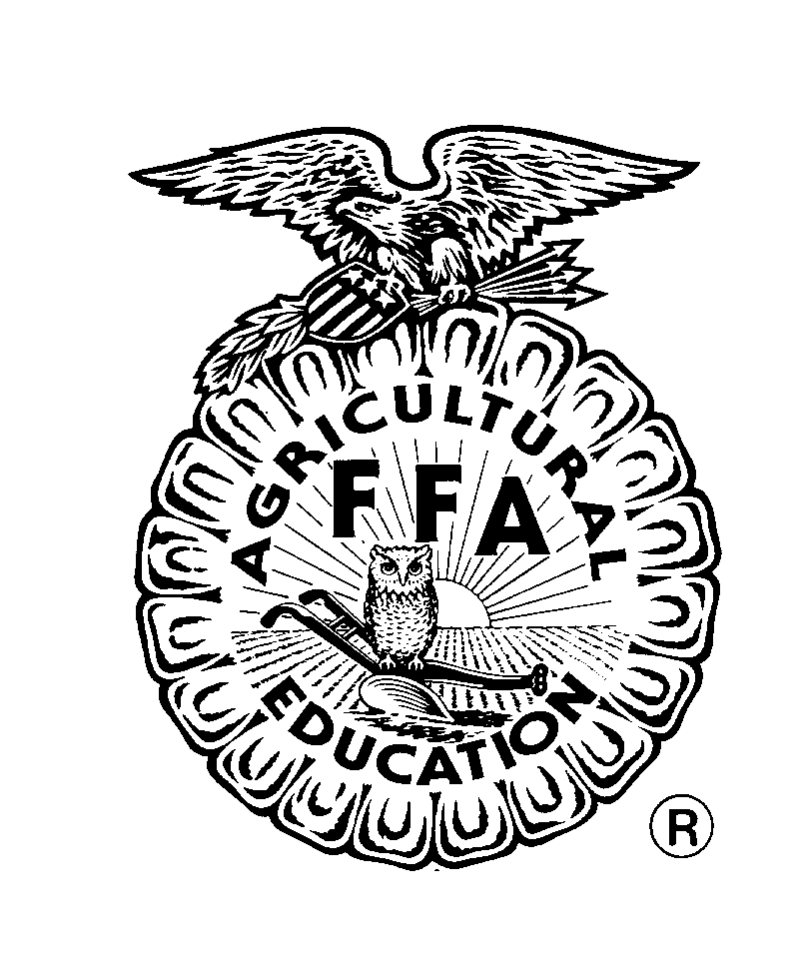
FAQ About Agriculture and Alturas FFA
Q. How do I become a member of the Alturas FFA?
A. In order to become a member of any California FFA Chapter, a student must be enrolled in an agriculture class at the high school level.

Q. Can I be a member of FFA and 4H?
A. You can be a member of both clubs. 4H is an excellent organization that offers some tremendous opportunities for students. FFA is also a wonderful organization that offers tremendous, but different opportunities for students. However, if you plan to raise animals, you can only count a species in one of the clubs record books. Example: You can raise/show beef in FFA and pigs in 4H. You cannot show market lambs in FFA and breeding sheep in 4H. You may transfer species from one program to another once in a calendar year. Ownership requirements per species still apply and an animal must be owned and documented in the students’ record book the required time prior to showing.

Q. Do I have to show an animal to be in FFA?
A. You do not have to show an animal to be in FFA. You may decide you want to, but you do not have to. There are many opportunities for students in FFA in addition to showing animals.

Q. How do I sign-up for FFA?
A. In California, by enrolling in an agriculture class, you are automatically enrolled in FFA.

Q. Do I have to attend meetings if I take an agriculture class?
A. You do not have to attend FFA meetings to be in an agriculture course; however you will need to attend 3 activities per semester. Those activities can be any of your choice. If you plan to show at the Alturas JLS as a member of the Alturas FFA, you must attend six meetings in the school year preceding the JLS. Example: If you plan to show at the 2010 JLS, you must attend a minimum of 6 meetings in the 2009-2010 school year.

Q. Can I take agriculture classes and still go to college?
A. Of Course! Depending on your specific plans following graduation, you may take agriculture classes as your science classes, or as elective courses. The Alturas FFA Advisor or MHS Counselor will be happy to help you plan a 4 year course plan that is custom to your plans following graduation.

If you have any additional questions, please feel free to call the MHS Agriculture Department Office at any time, 530-233-1824. Please leave a message if no one is available to answer the phone. If you prefer email, email Julie Harris at jharris@modoc.k12.ca.us.

